**BIGDATA LAB**

**Priyanka Dattatreya Hegde-C3**

**1NT20IS407**

Creating database in mongoDB

use priya407

switched to db priya407

insert one in mongoDb: db.collection.insertOne({Name:"arch",usn:"1NT20IS400", sec:"c",gender:"f",sub:"ise"})

{

"acknowledged" : true,

"insertedId" : ObjectId("6246f98d52780053e5aaea24")

}

> document.collection.find()



**INSERT MANY INTO MONGODB:**

> db.collection.insertMany([ { Name:"priyanka h",usn:"1NT20IS467", sec:"c",gender:"f",sub:"ise" },{ Name:"rohit",usn:"1NT20IS499", sec:"b",gender:"m",sub:"cse"},{ Name:"riya",usn:"1NT20IS599", sec:"1",gender:"f",sub:"eee"} ])

{

"acknowledged" : true,

"insertedIds" : [

ObjectId("6246f7b252780053e5aaea21"),

ObjectId("6246f7b252780053e5aaea22"),

ObjectId("6246f7b252780053e5aaea23")

]

}

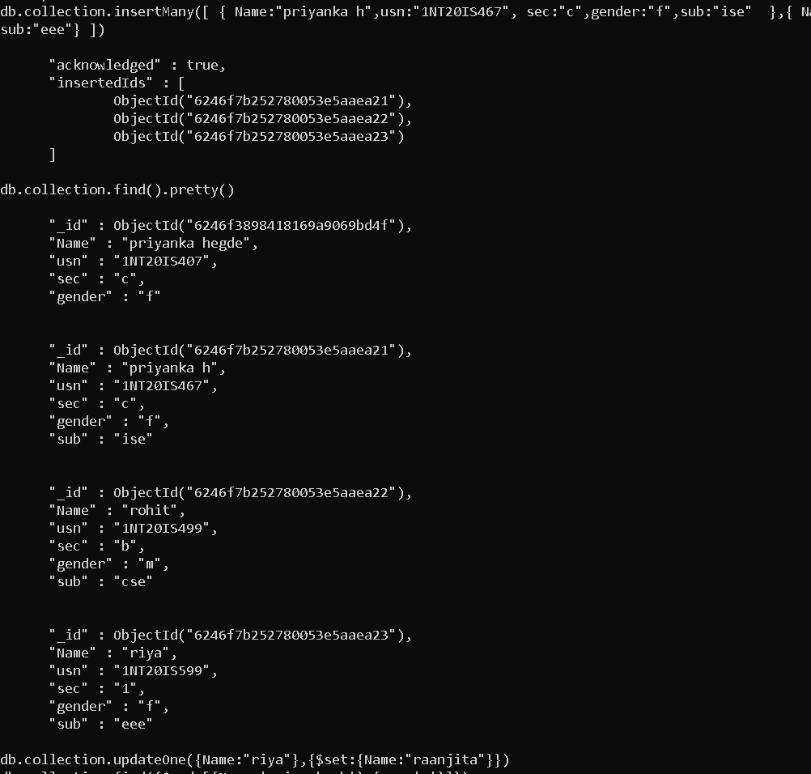

**UPDATEONE IN MONGODB:**

> db.collection.updateOne({Name:"riya"},{$set:{Name:"raanjita"}}})

{ "acknowledged" : true, "matchedCount" : 1, "modifiedCount" : 1 }

**OUTPUT:**

db.collection.find().pretty()

{

"_id" : ObjectId("6246f3898418169a9069bd4f"),

"Name" : "priyanka hegde",

"usn" : "1NT20IS407",

"sec" : "c",

"gender" : "f"

}

{

"_id" : ObjectId("6246f7b252780053e5aaea21"),

"Name" : "priyanka h",

"usn" : "1NT20IS467",

"sec" : "c",

"gender" : "f",

"sub" : "ise"

}

{

"_id" : ObjectId("6246f7b252780053e5aaea22"),

"Name" : "rohit",

"usn" : "1NT20IS499",

"sec" : "b",

"gender" : "m",

"sub" : "cse"

}

{

"_id" : ObjectId("6246f7b252780053e5aaea23"),

"Name" : "raanjita",

"usn" : "1NT20IS599",

"sec" : "1",

"gender" : "f",

"sub" : "eee"

}

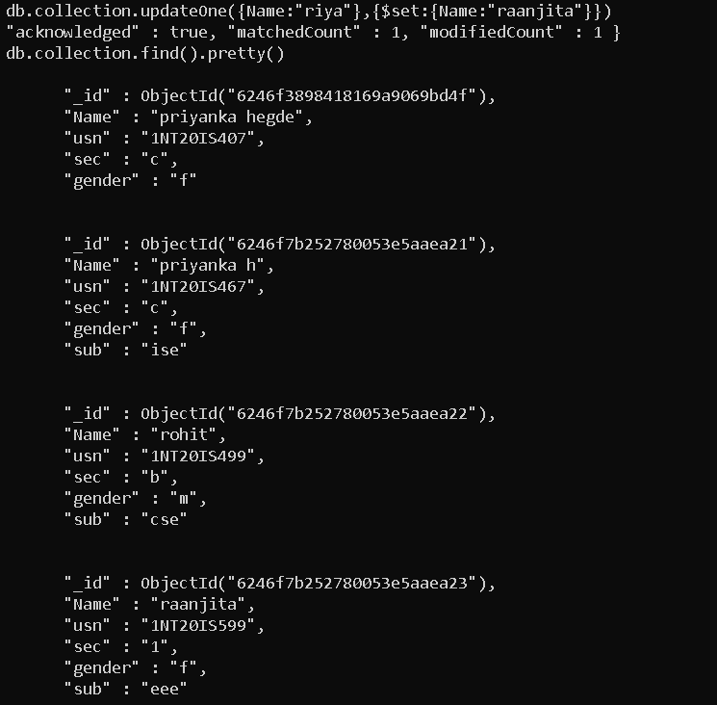

**DELETE MANY IN MONGODB:**

> db.collection.deleteMany({Name:'arch'})

{ "acknowledged" : true, "deletedCount" : 1 }

**SET FUNCTION IN UPDATE:**

db.collection.updateOne({Name:"raanjita"},{$unset:{Name:""}})

{ "acknowledged" : true, "matchedCount" : 1, "modifiedCount" : 1 }

**OUTPUT:**

> db.collection.find({})

{ "_id" : ObjectId("6246f3898418169a9069bd4f"), "Name" : "priyanka hegde", "usn" : "1NT20IS407", "sec" : "c", "gender" : "f" }

{ "_id" : ObjectId("6246f7b252780053e5aaea21"), "Name" : "priyanka h", "usn" : "1NT20IS467", "sec" : "c", "gender" : "f", "sub" : "ise" }

{ "_id" : ObjectId("6246f7b252780053e5aaea22"), "Name" : "rohit", "usn" : "1NT20IS499", "sec" : "b", "gender" : "m", "sub" : "cse" }

{ "_id" : ObjectId("6246f7b252780053e5aaea23"), "usn" : "1NT20IS599", "sec" : "1", "gender" : "f", "sub" : "eee" }

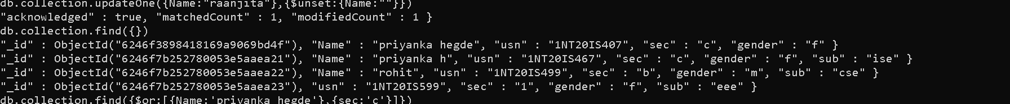

**OR OPERATION:**

db.collection.find({$or:[{Name:'priyanka hegde'},{sec:'c'}]})

**OUTPUT:**

{ "_id" : ObjectId("6246f3898418169a9069bd4f"), "Name" : "priyanka hegde", "usn" : "1NT20IS407", "sec" : "c", "gender" : "f" }

{ "_id" : ObjectId("6246f7b252780053e5aaea21"), "Name" : "priyanka h", "usn" : "1NT20IS467", "sec" : "c", "gender" : "f", "sub" : "ise" }



**AND OPERATION:**

db.collection.find({$and:[{Name:'priyanka h'},{sec:'c'}]})

**OUTPUT:**

{ "_id" : ObjectId("6246f7b252780053e5aaea21"), "Name" : "priyanka h", "usn" : "1NT20IS467", "sec" : "c", "gender" : "f", "sub" : "ise" }



**DROP OPERATION:**

> db.collection.drop()

true

